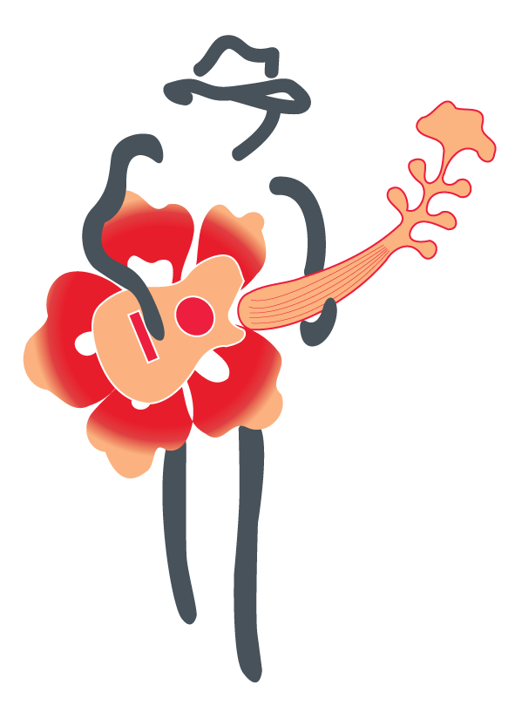

Event Schedule BJBF2019
THURSDAY, Feb. 21st
10:00 am New Orleans style parade starts from the Central Park to The Hotel Panamonte
11:00 am to 3:00 pm - Garden Party at The Hotel Panamonte
11:00 am - John Carney and 2B Live with Jimmie Hunter
12:30 pm - Matt Schofield
2:00 pm - Silvan Zingg
8:30 pm - 11:30 pm - Jam at Sabor Escondido - starting hosts - Matt Schofield and Anne Harris
After party at The Boquete Brewing Company
FRIDAY, Feb. 22nd
9:00 am to 11:00 am Breakfast, Mimosas, Bloody Marys and open Mic at Big Daddy’s - hosted by John Weeks
Concert at Valle Escondido
11:00 am - John Carney and 2B Live
12:30 pm - Lance Anderson
2:00 pm - Silvan Zingg
3:30 pm - Joe Louis Walker
8:30 pm - 11:30 pm - Friday Jam at Valle Escondido - starting hosted - Joe Louis
After party at The Boquete Brewing Company
SATURDAY, Feb. 23rd
9:00 am to 11:00 am Breakfast, Mimosas, Bloody Marys and open mic at Mike’s Global Grill - hosted by John Carney
Concert at Valle Escondido
11:00 am - Marshall Keys and Soulful Path
12:30 pm - Patricia Zarate
2:00 pm - Matt Schofield
3:30 pm - The Phantom Blues Band
8:30 pm - 11:30 pm - Saturday Jam at Boulder 54 - starting hosts - Silvan Zingg and Deanna Bogart
After party at The Boquete Brewing Company
SUNDAY, Feb. 24th
Concert at Valle Escondido
11:00 am - Rigoberto Coba
12:30 pm - The Melodious Mamas - Deanna Bogart, and Anne Harris
2:00 pm - Osvaldo Ayala
3:30 pm - Scott Ambush’s All Star Brigade
8:30 pm - 11:30 pm - Sunday Jam at Mike’s Global Grill - starting hosts - Lance Anderson and
Scott Ambush
After party at The Boquete Brewing Company

