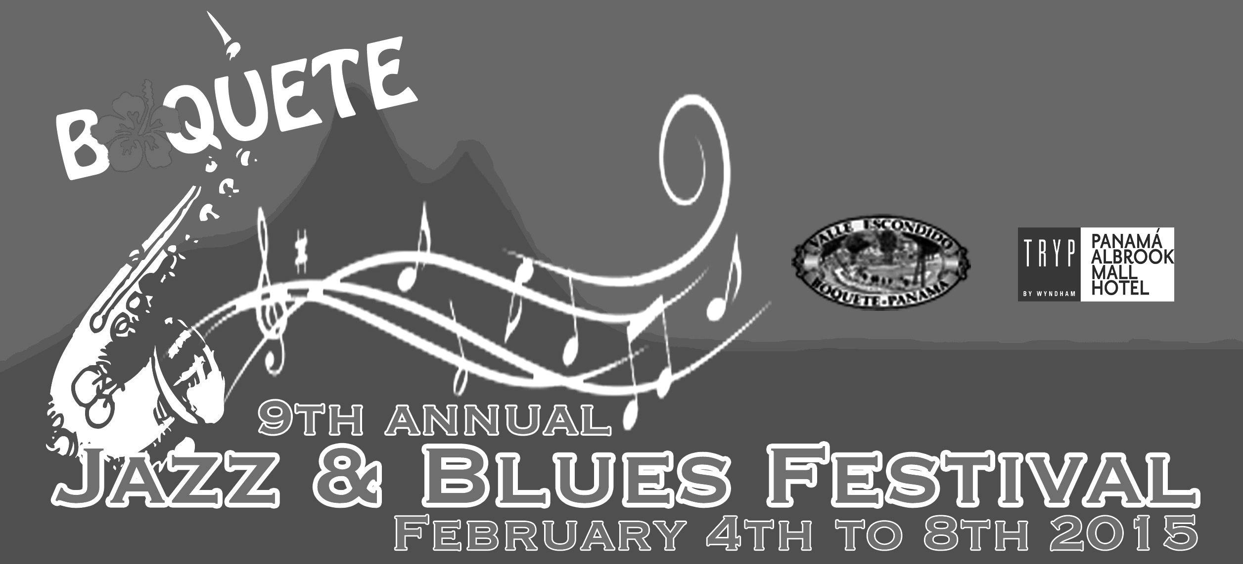
Preview program of the Boquete Jazz & Blues Festival 2015
(Subject to change)

Tuesday, February 3, 2015
3:30pm – 6pm Opening of the „Art of Music“ show complementing the Boquete Jazz&Blues Festival, at the Boquete Library. The artshow will run for two more weeks after the festival.
6pm: Fedora Club VIP party at Hotel Valle del Rio with the Fantazy Jazzband

Wednesday, February 04, 2015
Boquete goes New Orleans!
12pm – 1:30pm New Orleans style street parade (beads, costumes, umbrellas and all) in the streets of Boquete. Face painting & set-up starts at the BCP parking lot at 10am
1:30pm-5:00pm Garden party at the Panamonte hotel with live music. Admission $10
8pm - ??? Jam session at Mike’s Global Grill. Admission $15 at the door.

Thursday, Feb 05, 2015
2:30 – 4pm free concert in the central park of Boquete
5:00pm – 7:00pm Double bill show at the BCP: Leon Blue & John Carney. Admission $15
8pm - ???, Allstar jam session hosted by Andy Egert&B3, Leon Blue and Deanna Bogart. Admission $15 at the door. Baru restaurant.

Friday, Feb 06, 2015
3pm-6pm Open mike community Jam at Baru restaurant, Boquete. No cover
8pm - ??? , Blues allstar jam session. Hosted by Shakura S’Aida and Lil’ Ed&The Blues Imperials. Sabor restaurant, Valle Escondido.. Admission $15 at the door.
Saturday, February 07, 2015
12noon - 6pm Open-air festival at the amphitheatre at Valle Escondido
Doors open at 11 am
12:00pm – 1pm John Carney’s Gato Maximo
1:30pm – 2:30pm Deanna Bogart Band
3:00pm – 4:00pm Yelba&Latin Fire
4:30pm – 5:30pm Shakura S’Aida

8pm - ???, Latin Jazz allstar jam session, hosted by Yelba&Latin Fire and Malamanya at The Rock restaurant. Admission $15 at the door

Sunday, February 08, 2015
12 noon - 6pm Open-air festival at the amphitheatre at Valle Escondido
Doors open at 11 am
12:00pm – 1:00pm R. Coba Big Band
1:30pm – 2:30pm Andy Egert, Leon Blue &
Boquete Blues Band
3:00pm – 4:00pm Lil’ Ed & The Blues
Imperials
4:30pm – 5:30pm Malamanya

8pm -??? Blow-out jam session with Andy Egert & friends. Mike’s Global Grill. Admission $10 at the door.

Tickets:
One-day tickets for Feb 07 or 08: $35 per day
Two-day pass: $55

Free access for children up to 12 years if accompanied by an adult

Tickets are available online via our website at
http://www.boquetejazzandbluesfestival.com/tickets.html
Buy your tickets locally at Mailboxes ETC. in Boquete, David and Coronado, at the Tuesday market in Boquete and at the Valle Escondido hotel.

Admissions for the jam sessions will be collected at the door. Admission to all jams is free for Fedora Club members.

The festival venue
Our beautiful festival venue will again be the replica of an ancient Greek amphitheatre situated in the lush tropical surroundings of Boquete's beautiful "Valle Escondido" (the hidden valley), an upscale residential resort & spa community. Excellent acoustics and unobstructed views of the stage from all seats are assured! Sun & light rain protection is advisable. Small umbrellas only please! Pets and coolers are not permitted in the venue. Our drink and food vendors will be happy to cater for your needs, and you’ll support the festival by patronizing them!
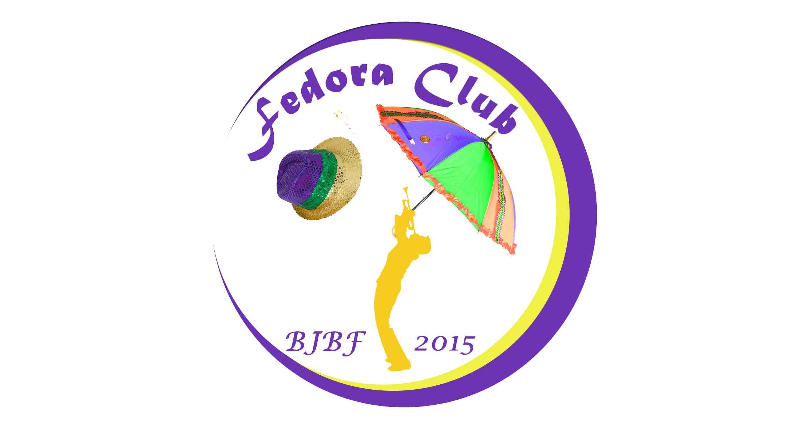
Join the BJBF Fedora Club to gain VIP status and receive benefits of about $220 per person plus $80 savings for each stay at the Albrook TRYP hotel in Panama City valid until Dec. 31, 2015! Check details on the Fedora page of our website.

Membership fee is $160 only per person

The club is limited to 150 members only!
Check out details and join the club online via our website. You may also join the club by dropping your cheque or cash at Mailboxes ETC. in Boquete! Cheques should be made out to: „Boquete Jazz&Blues Festival Foundation“ Don’t forget to leave your contact details so we can reach you!
www.boquetejazzandbluesfestival.com

